Degenfeldstr.5 Tel: +49(0)89. 2710386 Dr. Sebastian Wolf
80803 München mobil: +49(0)172.5939659
wolf@sebastianwolf.com Training, Coaching, Mediation, Teamentwicklung, Organisationsberatung

Dr. Sebastian Wolf
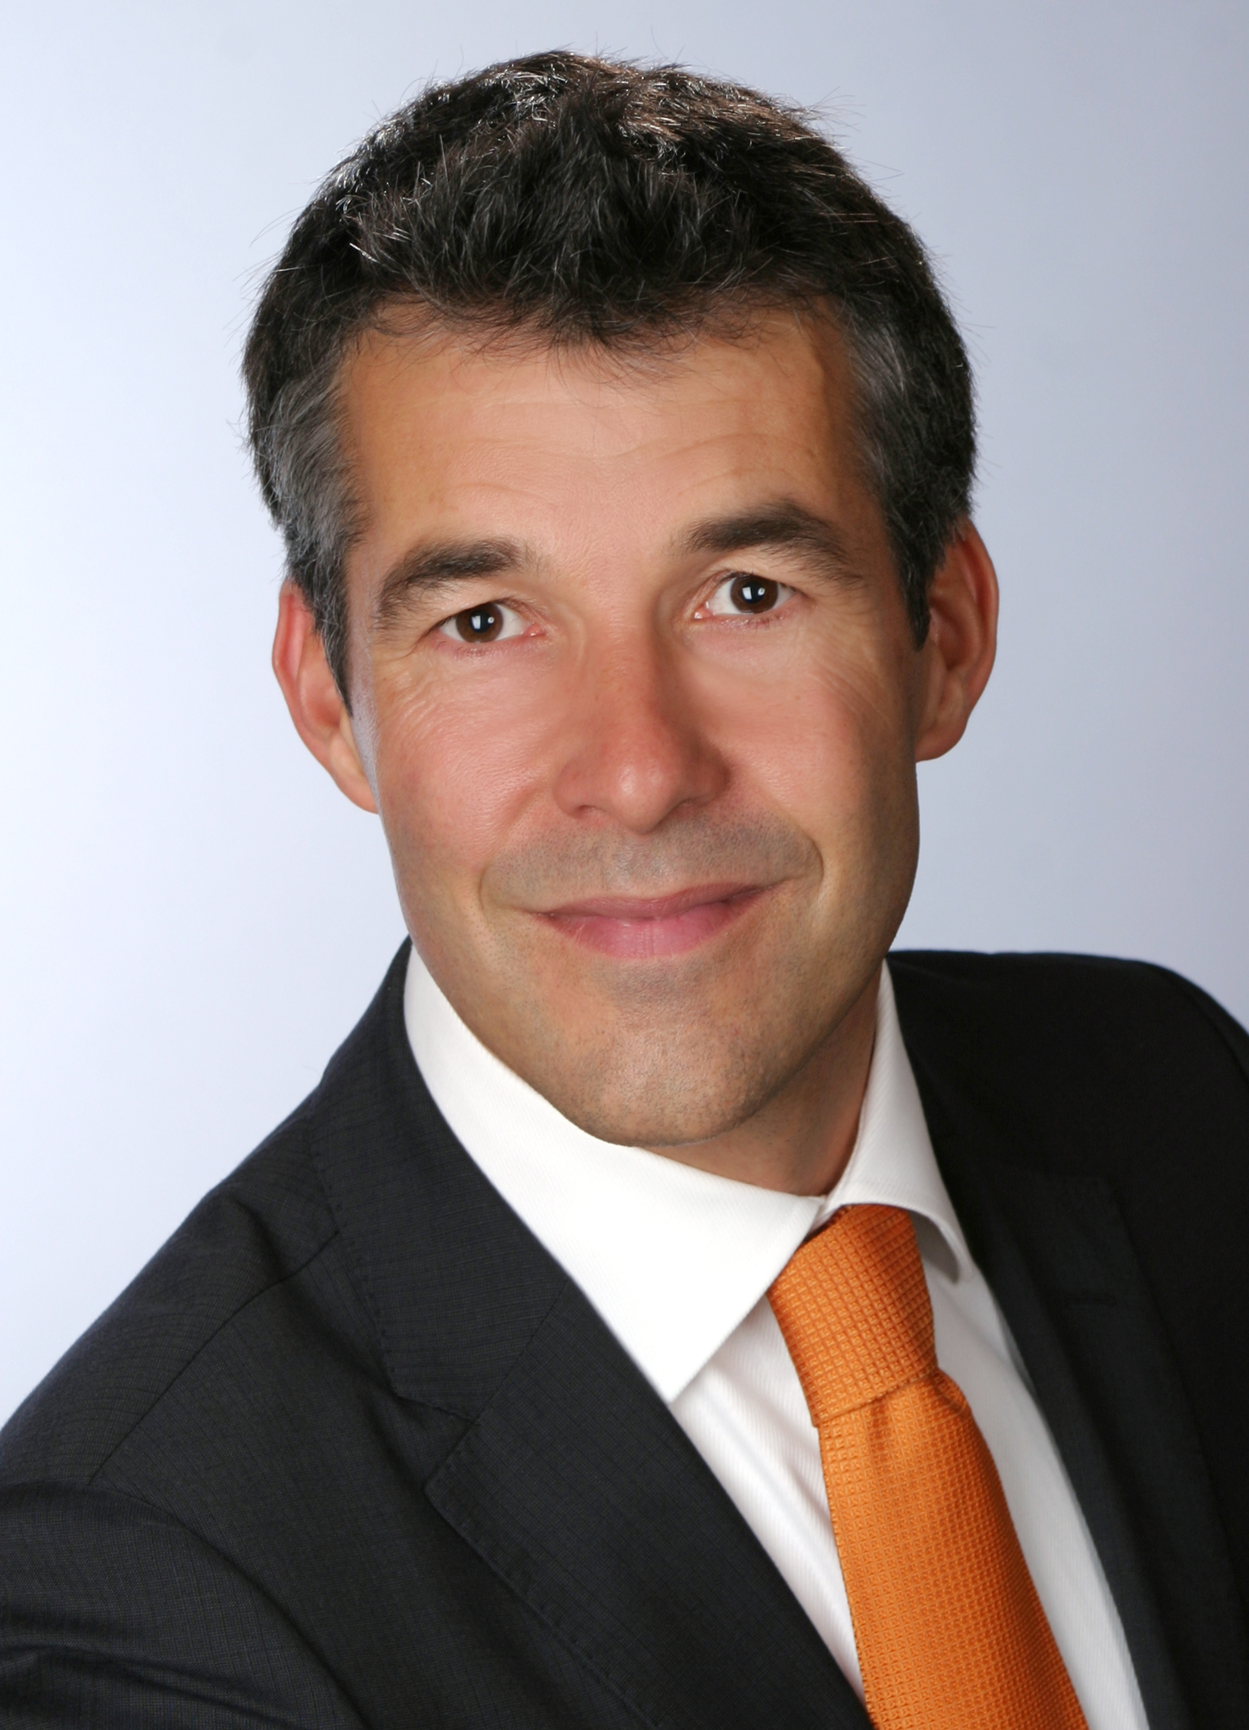

Education - Medical School at the University of Heidelberg, London, Chicago, Toronto and New
York (sponsored by the German National Academic Foundation and the DAAD
(German Academic Exchange Service))
- Doctoral thesis about the effects of stress and conflict behavior in people with
increased risk of heart attacks
- Advanced training in the area of stress related disorders and medicine
- Additional diplomas in systemic organizational consulting, mediation and
organizational development
- Further education in coaching, training and moderation at the Academy of
HypoVereinsbank (HVB) in Munich

Professional Profile

2002 - today Lecturer and Project Director for leadership topics at Boston Business School and several St. Gallen based Business Schools
2002 - today Coach and lecturer Allianz SE (Munich)
2003 - today Coach and trainer for BMW (Munich)
2004 - today Coach and trainer for Telefonica/o2 Germany (Munich)
1999 - today Lecturer and coach at HypoVereinsbank (HVB) academy (Munich)
2006 - today Professor of Leadership at MBA Program at the University of Krakow (Poland)
1999 - today Senior Consultant and Medical Co-Director at a crisis center with 1.000 clients/ year
1992 -1999 Clinical practice as a medical doctor in several areas of internal medicine and emergency medicine

Activities - Leadership seminars (open enrollment and in-house) with focus on:
Management of stress, conducting of meetings, presentation, negotiation, conflict
management, coaching of employees, effective leadership, change management &
organizational consulting
- Executive coaching with focus on personality development and stress prevention
- Conflict analysis and mediation
- Communication in organizations, organizational diagnostics
- Moderation of remote meetings for planning and reflection
- Team development, kick-off meetings
- Guest speaker, key note speaker

References Allianz SE
BMW AG
Deutsche Bank AG
Deutsche Post AG
Gruner+Jahr Verlagshaus
Unicredit Hypovereinsbank München AG
Iteratec Informationssysteme GmbH
KSB Frankenthal AG
Mercer Consulting Europe
MLP Finanzdienstleistungen Heidelberg
Monitor Consulting Madrid
Münchener Rückversicherungsgesellschaft AG
Novartis Pharma AG
Telefonica/o2 Germany München AG
Pioneer Investment AG
Plan Central Supply Chain Management, New York, USA
Pfizer Pharma GmbH
ProSiebenSat1 Media AG
SAP AG Walldorf,
Springer Verlag Heidelberg
Süddeutscher Verlag München
Telekom AG
TÜV Rheinland International
United Health Group Inc.
Sedgwick Parekh Bombay
Weber Tool & Mold Toronto, Canada

